Research Report on:- Insufficient Cryptography, Poor Code Quality, Code Tampering, and Reverse Engineering in Mobile Applications



Introduction
Mobile applications have become integral to our daily lives, providing convenience, connectivity, and accessibility. However, as their usage grows, so do the security threats targeting these applications. Among the most significant security concerns are insufficient cryptography, poor code quality, code tampering, and reverse engineering. This report delves into each of these vulnerabilities, their methods, and their implications for mobile application security.

Insufficient Cryptography


Definition
Insufficient cryptography occurs when cryptographic techniques are improperly implemented, leading to weakened data protection. This vulnerability enables attackers to intercept, decrypt, or manipulate sensitive data, compromising confidentiality, integrity, and authenticity.

Methods
- Weak Algorithms: Using outdated or insecure cryptographic algorithms, such as MD5 or SHA-1, which are vulnerable to brute force and collision attacks.
- Improper Key Management: Failing to securely generate, store, or distribute cryptographic keys, leading to unauthorized access.
- Lack of Encryption: Transmitting or storing sensitive data in plaintext without encryption, exposing it to interception.
- Hardcoded Secrets: Embedding cryptographic keys, passwords, or tokens directly in the source code, making them easily retrievable through reverse engineering.

Implications
- Data breaches
- Identity theft
- Financial fraud

Poor Code Quality


Definition
Poor code quality refers to software development practices that result in insecure, unoptimized, or unstable code. This increases the risk of vulnerabilities that can be exploited by attackers.

Methods
- Lack of Input Validation: Failing to validate user inputs can lead to injection attacks, such as SQL injection or XSS.
- Code Smells: Issues like duplicated code, overly complex structures, and excessive dependencies introduce security gaps.
- Improper Error Handling: Revealing sensitive information, such as stack traces or error messages, which can aid attackers.
- Outdated Libraries: Using libraries or frameworks with known vulnerabilities, exposing the application to exploitation.

Implications
- Increased attack surface
- Application crashes
- Unauthorized access

Code Tampering


Definition
Code tampering involves unauthorized modifications to an application’s source code or binary, often to introduce malicious functionality or bypass security mechanisms.

Methods
- Repackaging Applications: Altering legitimate app binaries and redistributing them with malicious code or advertisements.
- Runtime Hooking: Using tools to manipulate application behavior at runtime, often to bypass security checks.
- Injection Attacks: Embedding malicious scripts or code into the application to execute unauthorized actions.

Implications
- Malware distribution
- Loss of user trust
- Unauthorized access to premium features

Reverse Engineering
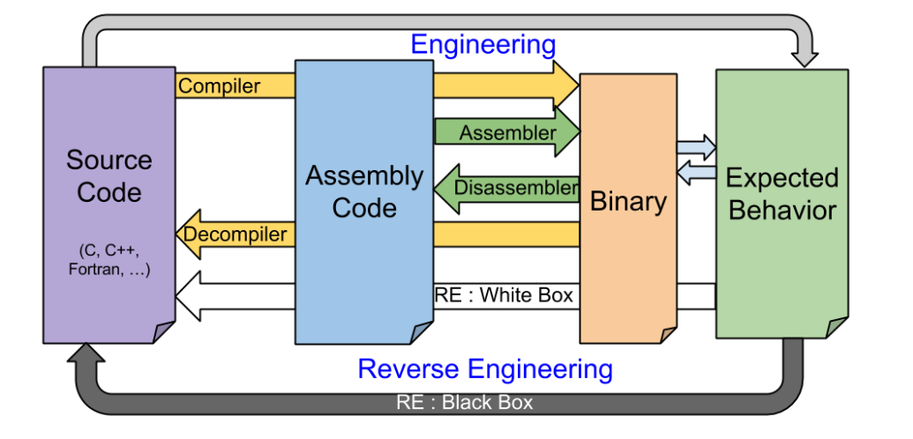

Definition
Reverse engineering is the process of analyzing an application’s binary or source code to understand its functionality, logic, or vulnerabilities. This technique is often used by attackers to identify and exploit weaknesses.

Methods
- Decompilers: Tools like JADX or APKTool to convert binary code back into human-readable source code.
- Dynamic Analysis: Observing application behavior at runtime using tools like Frida or Xposed.
- Static Analysis: Inspecting the application’s source code, configuration files, and resources without executing it.

Implications
- Intellectual property theft
- Exposure of sensitive algorithms or keys
- Facilitation of other attacks, such as code tampering or cryptographic key extraction

Conclusion
Insufficient cryptography, poor code quality, code tampering, and reverse engineering pose significant threats to mobile application security. Developers must adopt best practices such as secure coding, regular code reviews, and robust cryptographic implementations to mitigate these risks. Additionally, organizations should employ penetration testing and application hardening techniques to safeguard their applications against sophisticated attacks.

References
- OWASP Mobile Security Testing Guide. (2025). OWASP.
- Stallings, W. (2017). Cryptography and Network Security: Principles and Practice. Pearson.
- Android Developers Guide. (2025). Android Developers.
- iOS Security Guide. (2025). Apple Developer.
- Xia, Y., et al. (2020). "Mobile Application Security: Challenges and Future Directions." Journal of Cybersecurity.
- Symantec Threat Report. (2024). Symantec.

